Scholastic Inc., 557 Broadway, New York, NY 10012, Attn: Karen Fuchs, Ph: 212-343-4447

Date 10/14/2020

RE: Chemicals of High Concern to Children (CHCC) Declaration /
California Proposition 65 Declaration Letter / Flame Retardant Declaration
Title: DOUBLE WIDE BOOK BIN BLACK ISBN: 71130E06C P.O. #: 5026642
Product Manufacture date: 09/2020 Vendor: Storex Ind. Corp.

Mark as applicable:
Contains reportable chemicals of high concern for children. If yes, provide the following information:
Component | Reportable Chemical | Concentration | State(s) requiring reporting | Reported by vendor (Y/N) | Date Reported
Does not contain reportable chemicals of high concern for children

Contains a California Prop 65 chemical that requires a Prop 65 warning label. If yes, provide the following:
Component | Prop 65 chemical | Risk of Harm (Check all that apply) |  |  | Warning Language
 |  | Cancer | Birth Defects | Reproductive Harm
Does not contain a California Prop 65 chemical that requires a Prop 65 warning label.

Contains Flame retardants as outlined by regulations listed below. Check all applicable and provide info requested.
☐Washington RCW 70.240.025-Children’s Products and Residential Upholstered Furniture-Flame Retardants Content (5FR)
☐Regulation (EC) No. 1907/2006-REACH-Flame Retardants (DecaBDE, Decabromodiphenyl Ether)
☐Regulation (EC No. 1907/2006-REACH-Flame Retardants (OctaBDE, Octabromodiphenylether)
☐Regulation (EC) No. 197/2006-REACH-Flame Retardants Content (4 FR-TRIS/PBBs/TEPA/OctaBDE)
Applicable Regulation | Component/Material | Flame Retardant
Does not contain flame retardants covered by above noted regulations.

Sign and date below and submit to ProductSafety@Scholastic.com.
GILAD BEN-OR, VP MARKETING
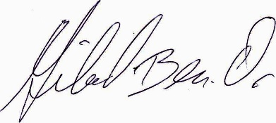
Name of Issuer & Title
14/oct/2020

Signature Date

