Children's Product Certificate
Date of Certificate: 23 September 2022

Product Overview

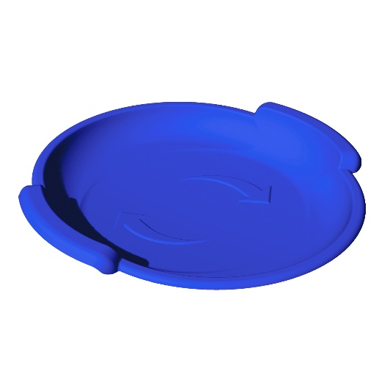

Product Reference Image

Product Name: | 3000940- 24x24 “Spiral” Sled (Blue)
Date of Manufacture: | Aug. 2022
Place of Manufacture: | 2500 Guenette  Saint Laurent, QC  H4R 2H2
Imported By: | Era Group Ltd.
Manufacturer: | Era Group Ltd.
Part Number: | Multiple

Testing and Records Overview

Test Date: September 23,2022
Test Location and Contact Information
Cambridge Materials Testing Limited
6991 Millcreek Drive, Unit 13
Mississauga, Ontario L5N 6B9
Canada
(905) 812-3856

Certification Issued and Test Records Maintained By
Era Group Ltd.
2500 Guenette
Saint Laurent, QC H4R 2H2
Canada
Gilad Ben-Or
giladb@storex.ca

Era Group Ltd. certifies that the above product complies with the following rules bans, regulations and standards:

- US Consumer Products Safety Improvement Act of 2008:
  - Section 101 Products containing Lead
  - Section 108 Products containing Phthalates
  - Section 106 Mandatory Toy Safety Standards
- ASTM F963-17 Standard Consumer Safety Specification for Toy Safety
- Canada Consumer Product Safety Act: Toys Regulation (SOR/2011-17)
- CPSC-CH-E1002-08.3 Standard Operating Procedure for Determining Total Lead (Pb) in Nonmetal Children’s Products
- CPSC-CH-C1001-09.4 Standard Operating Procedure for Determining of Phthalates
- 16 CFR 1500.44 Method for Determining Extremely Flammable and Flammable Solids
- 16 CFR 1500.48 Technical Requirements for Determining a Sharp Point in Toys and Other Articles Intended for Use by Children Under 8 Years of Age
- 16 CFR 1500.49 Technical Requirements for Determining a Sharp Metal or Glass Edge in Toys and Other Articles Intended for Use by Children Under 8 Years of Age
- 15 CFR 1501 Method for Identifying Toys and Other Articles Intended for Use by Children Under 3 Years of Age which Present Choking, Aspiration, or Ingestion Hazards Because of Small Parts.
- Health Canada Method M00.1 Small Components (Effective 2019-07-02)
- Health Canada Method M00.2. Sharp Edges (Effective 2021-04-22)
- Health Canada Method M00.3 Sharp Points (Effective 2021-01-15)
- Health Canada Method M01.1 Reasonably Foreseeable Use – Toys (Effective 2019-02-18)

