- Identification of the product covered by this certificate:
Certificate No.: | HK22112310611R
Sample Name: | Era Snowflake Infant Sled
Model No: | 6598308
Trade Mark: | ERA
Sample Description: | Children skating toys
ASIN: | N/A
As shown in the Test Report No.: | HK22112310611-1RR
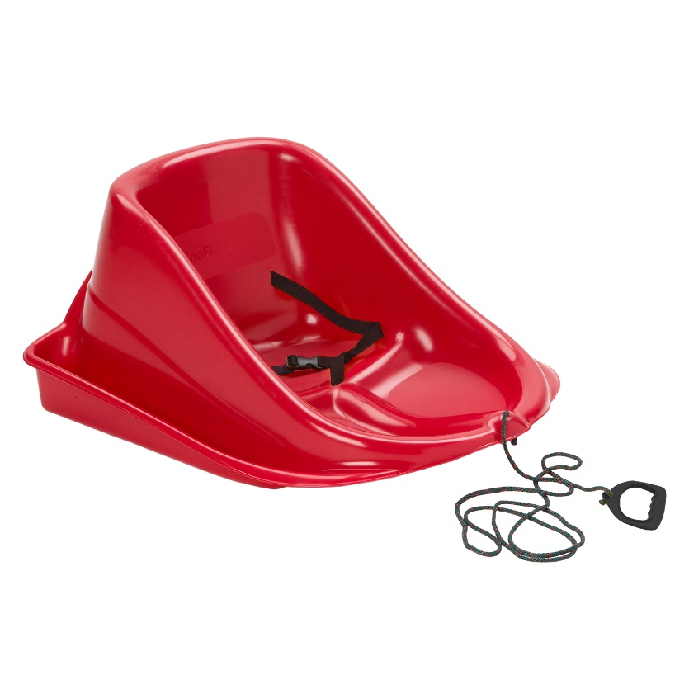
- Age grading: 3 to 12 months

- Citation to each CPSC children’s product safety rule to which this product is being certified:
Applicable Standard(s)
As specified in title 16, code of federal regulations, chapter II- consumer products safety commission of U.S.A
- 16 CFR 1500.48 Sharp point
- 16 CFR 1500.49 Sharp edge
- 16 CFR 1501 Small Objects
16 CFR 1500.3 (C) (6) (vi) Definition of “Flammable Solid", refer to
16 CFR 1500.44 Method for determining extremely flammable and flammable solids.
ASTM F963-17 Standard Consumer Safety Specification for Toy Safety
1.-Mechanical and Physical Tests
ASTM F963-17 Section 4.6 Small Objects
ASTM F963-17 Section 4.7 Accessible Edges
ASTM F963-17 Section 4.9 Accessible Points
ASTM F963-17 Section 4.11 Nails and Fasteners
ASTM F963-17 Section 4.15 Stability and Over-Load Requirements
ASTM F963-17 Section 4.39 Jaw Entrapment in Handles and Steering Wheels
- USA Consumer Product Safety Improvement Act (CPSIA) Sec.101 Children´s products containing Lead; Lead paint rule (CPSC-CH-E1002-08.3 Standard Operating Procedure for Determining Total Lead (Pb) in Nonmetal Children’s Products)
- USA Consumer Product Safety Improvement Act (CPSIA) Sec.108 Prohibition on sale of certain products containing specified phthalates
- USA 16 CFR Part 1307 Prohibition of Children’s Toys and Child Care Articles Containing Specified Phthalates (CPSC-CH-C1001-09.4 Standard Operating Procedure for Determination of Phthalates)
-CPSA Section 14(a) (5) Tracking Labels for Children's Products (15 USC §2063(a)(5) (CPSA))

- Identification of the U.S. importer or domestic manufacturer certifying compliance of the
product :
Importer: | ERA Group Inc.
Address : | 2500 Guenette, Saint-Laurent, Qc, Canada H4R2H2
Phone: | 514-335-0550
Email: | lgagnon@eragroup.ca
Contact: | Luc Gagnon

- Contact information for the individual maintaining records of test results:

Applicant : | Era Group Inc.
Address: | 2500 Guenette, Saint-Laurent, Qc, Canada H4R2H2
Contact: | Luc Gagnon
Address: | N/A
Phone: | 514-335-0550
Email: | lgagnon@eragroup.ca

- Date and place where this product was manufactured:

Certificate No.: | HK22112310611R
Applicant: | Era Group Inc.
Address: | 2500 Guenette, Saint-Laurent, Qc, Canada H4R2H2
Manufacturer: | Era Group Inc.
Address: | 2500 Guenette, Saint-Laurent, Qc, Canada H4R2H2
Phone: | 514-335-0550
Manufacture Date: | N/A
Manufacture Place: | 2500 Guenette, Saint-Laurent, Qc, Canada H4R2H2
Manufacturer Part Number: | N/A

- Provide the date(s) and place when the product was tested for compliance with the consumer
Product safety rule(s) cited above:

Testing Date | November 30, 2022
Address | Shenzhen city, Guangdong Province, China

8. Identify any third party, CPSC-accepted laboratory on whose testing the certificate depends:
Third Party laboratory | Shenzhen HUAK Testing Technology Co., LTD.
Address | 1-2/F., Building B2, Junfeng Zhongcheng Zhizao Innovation Park, Heping Community, Fuhai Street, Bao'an District, Shenzhen, Guangdong, China
Phone | + (86)755 2302 9901
Email | service@cer-mark.com
Online | http://www.cer-mark.com
CPSC lab ID | 1710
Manufacturer's seal:
November 30, 2022

